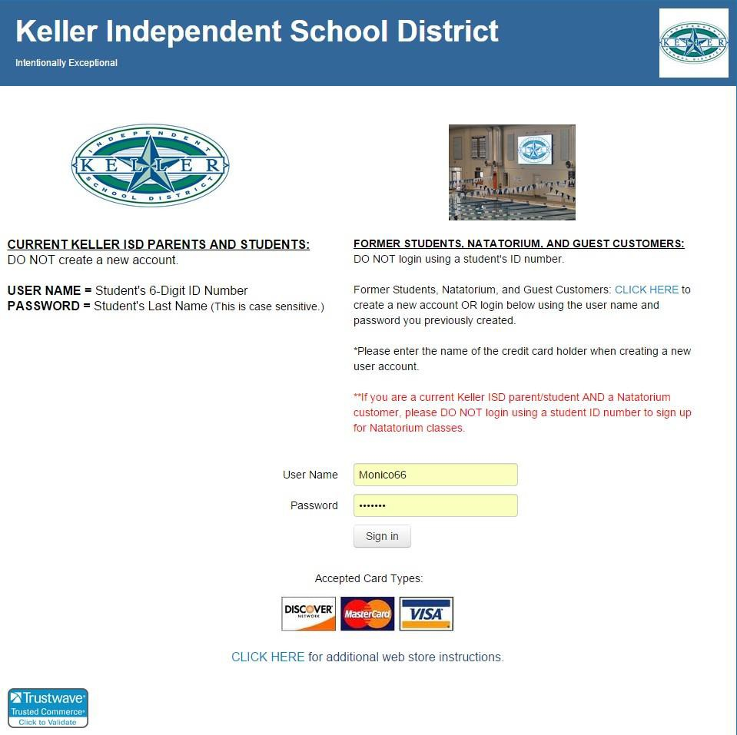

IF YOU DO NOT HAVE AN ACCOUNT, PLEASE CREATE ONE BY CLICK- ING THE BLUE LINK ON RIGHT SIDE OF THE PAGE. ACCOUNT
NEEDS TO BE UNDER A PARENT’S NAME, NOT THE CHILD.

ONCE ACCOUNT IS CREATED, LOGIN BELOW BY ENTERING YOU INFORMATION AND CLICK “SIGN IN”

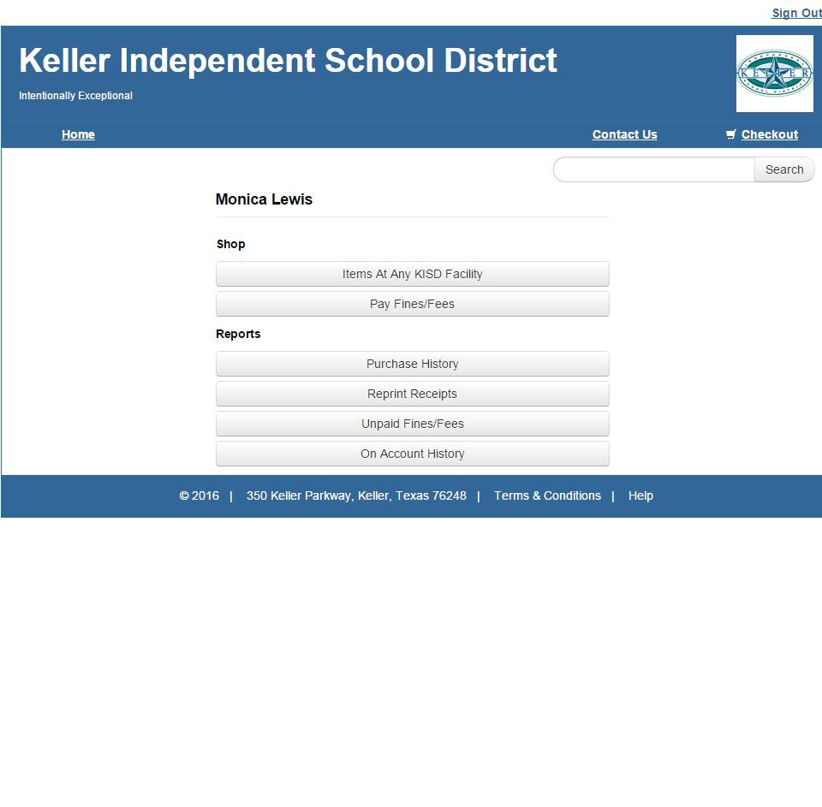

CLICK HERE

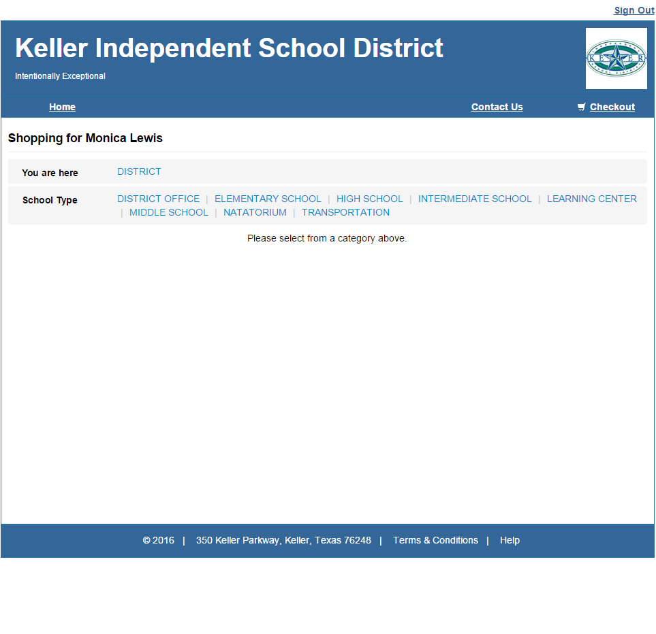

CLICK “NATATORIUM”

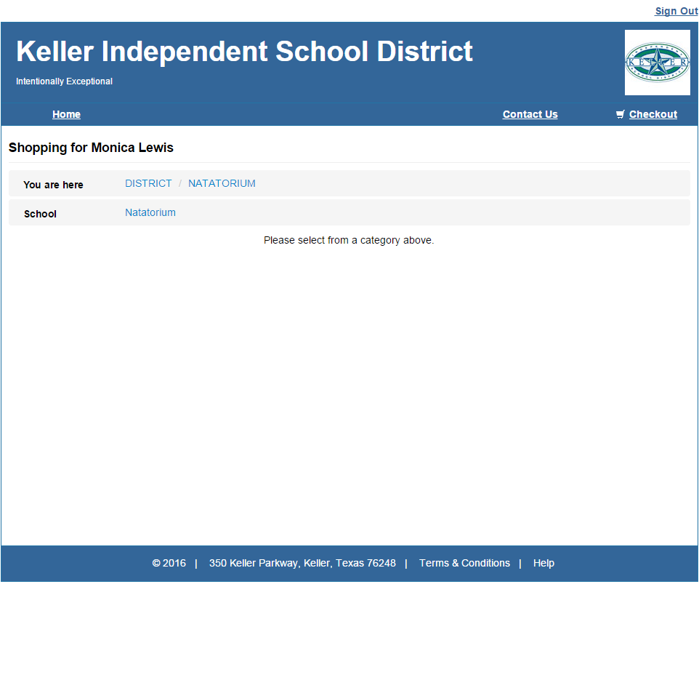

CLICK “NATATORIUM” AGAIN

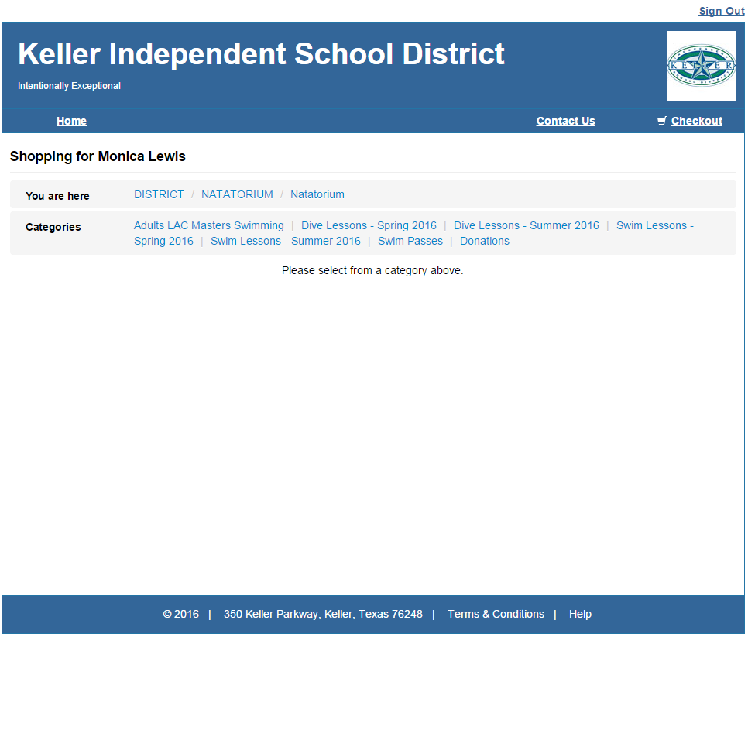

MAKE YOUR SELECTION. YOU CAN CHOOSE SWIM OR DIVE LESSONS. THE EXAMPLE IN THE NEXT FRAME WILL BE FOR SWIM LESSONS

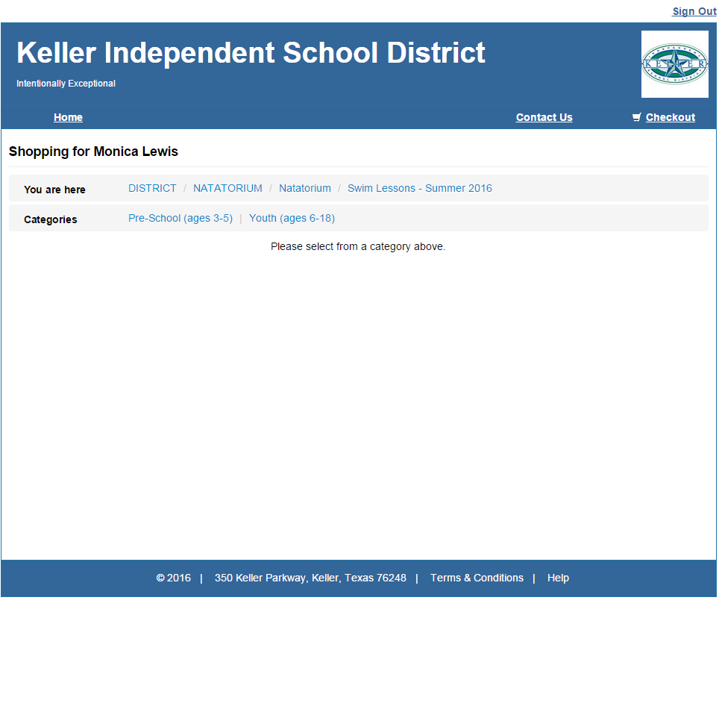

SELECT AGE GROUP. THIS EXAMPLE
WILL BE FOR “YOUTH”

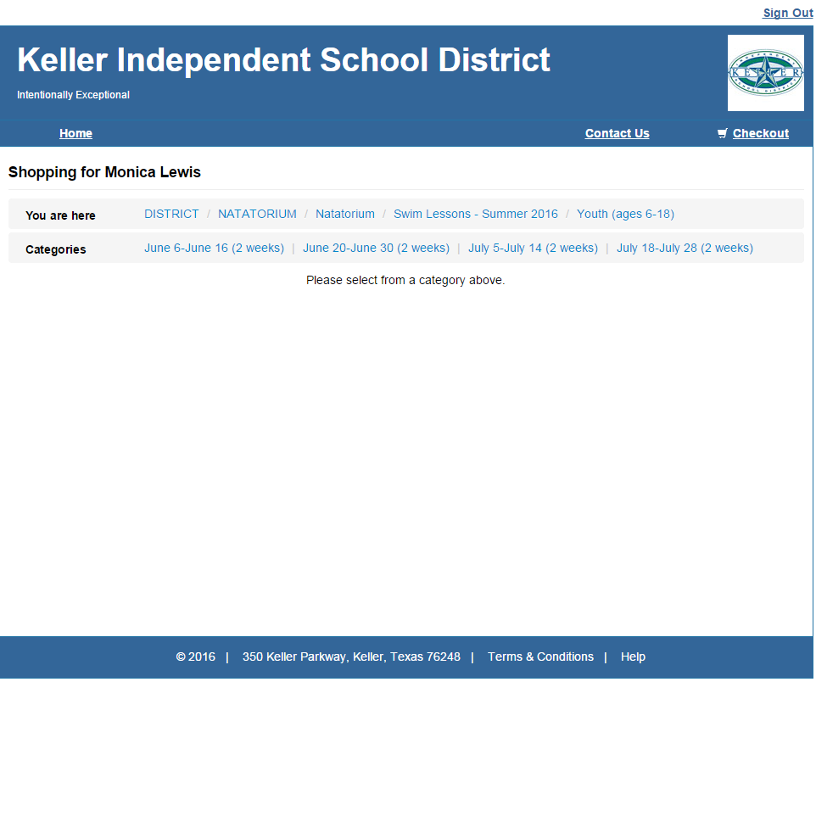

SELECT DATE/SESSION

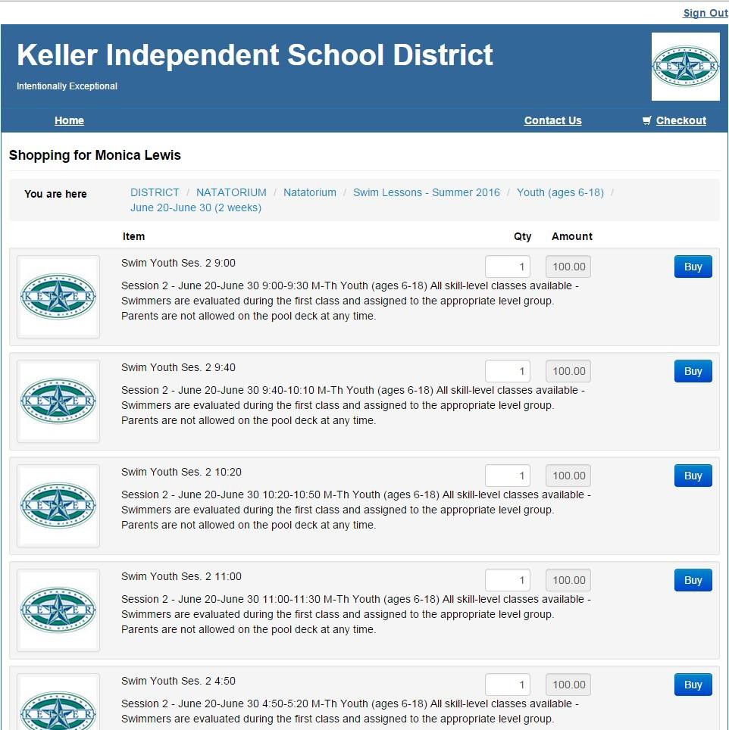

SELECT CLASS DAY/
TIME AND CLICK “BUY”.

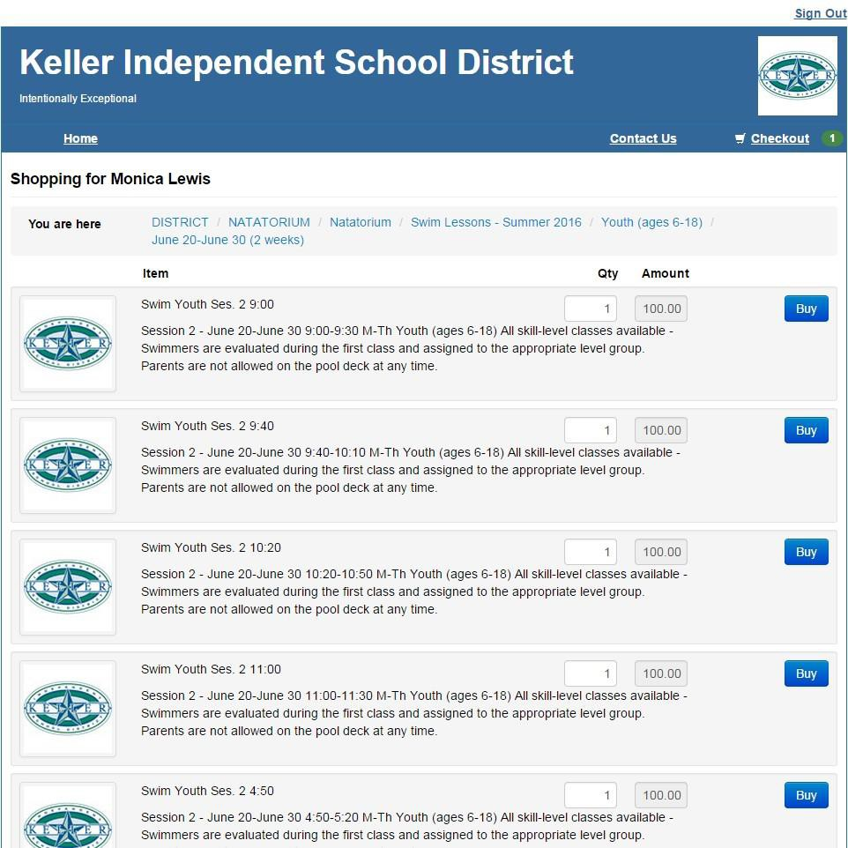

YOUR PURCHASE IS NOW IN YOUR CART. CLICK “CHECKOUT”

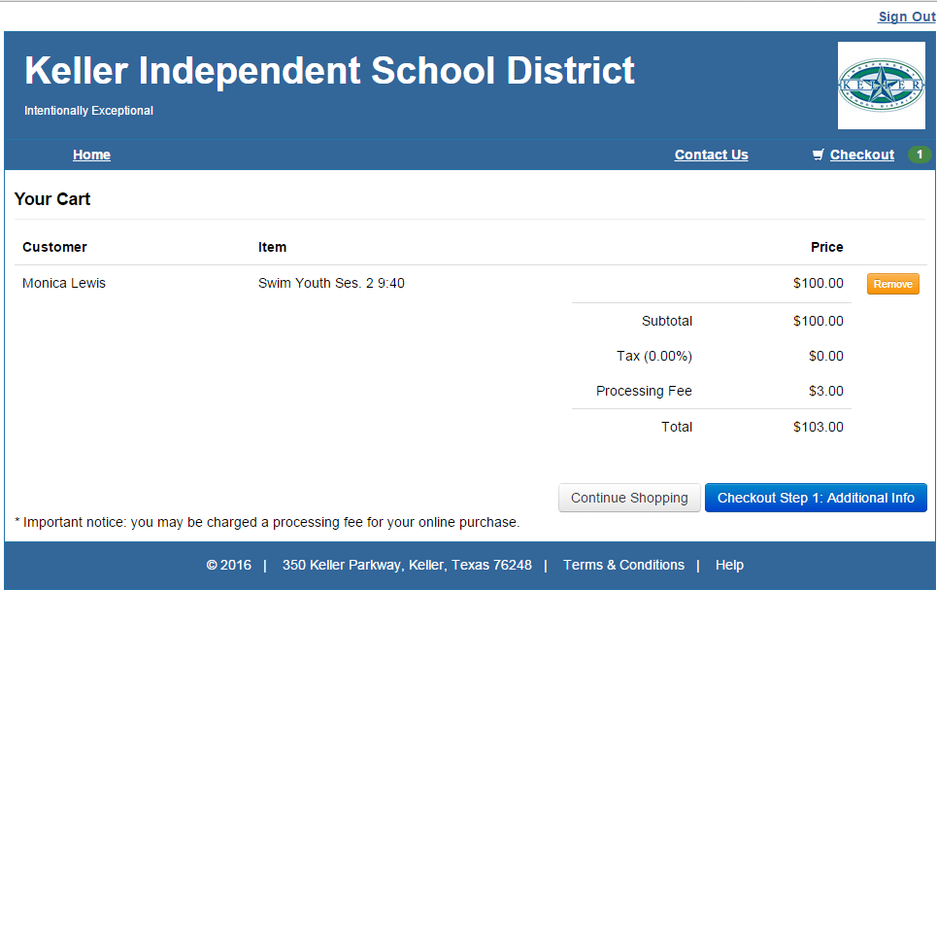

CLICK BLUE LINK.

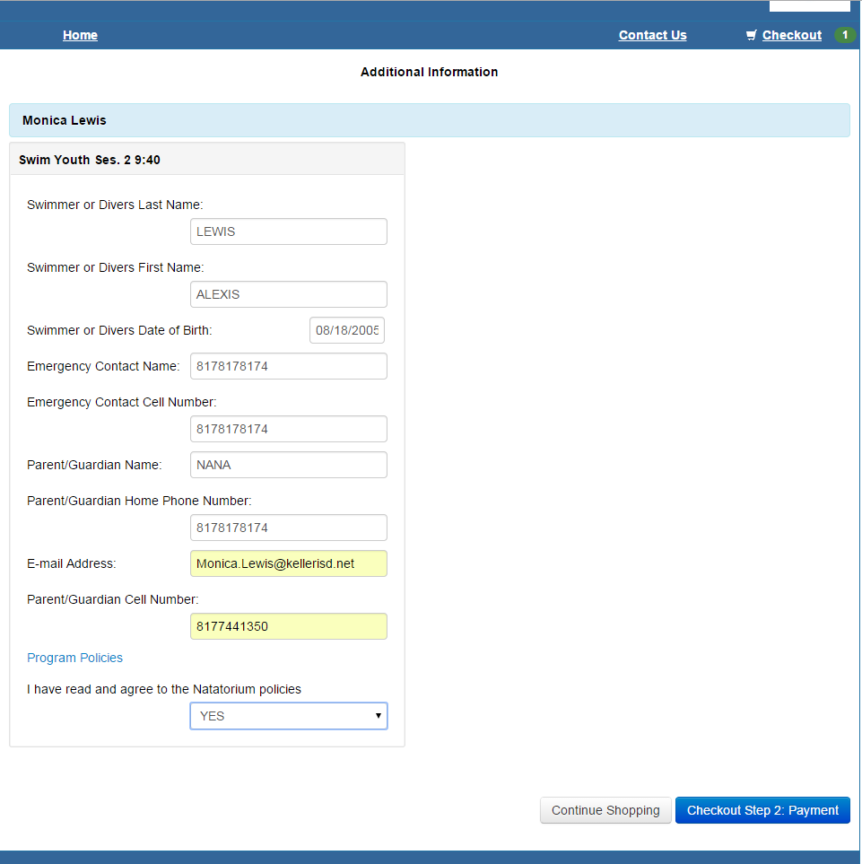

FILL IN CHILD’S INFORMATION

CLICK “PAYMENT”

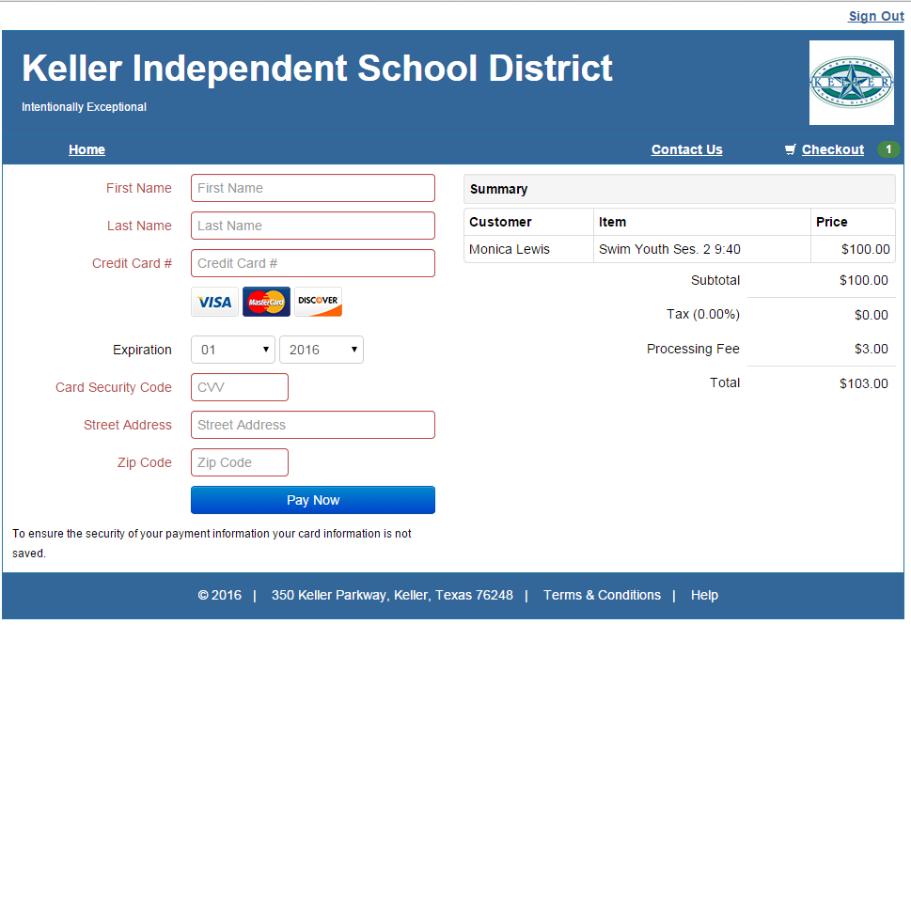

CHECK CLASS DATES/TIMES CAREFULLY BEFORE SUBMITTING PAYMENT

SEE REFUND & TRANSFER POLICIES BELOW

FILL IN PAYMENT INFORMATION AND CLICK “PAY NOW”.

***YOU WILL BE ASKED TO READ OUR TRANSFER/REFUND POLICIES BEFORE PURCHASE CAN BE COMPLETED. IT IS YOUR RESPONSIBILITY TO READ & UNDERSTAND POLICIES BEFORE PROCEEDING*** (SEE POLICIES BELOW)

YOU WILL NOT RECEIVE A CONFIRMATION EMAIL OF YOUR PURCHASE OR A REMINDER OF CLASS DATE/TIME.

**PLEASE NOTE** WHEN REGISTERING MULTIPLE CHILDREN, THE RECEIPT MAY ONLY CAPTURE THE FIRST CHILD. PLEASE DO NOT REGISTER AGAIN BEFORE CHECKING YOUR BANK ACCOUNT TO SEE
IF YOU WERE CHARGED CORRECTLY. WE ARE WORKING TO FIX THIS ISSUE. IF A REFUND IS REQUIRED, IT WILL TAKE APPROX. 30 DAYS TO RECEIVE. REFUNDS ARE ISSUED VIA CHECK ONLY AND CANNOT BE DEBITED BACK TO YOUR CARD.

**IPHONE & IPAD USERS**ONCE YOU REGISTER YOU WILL NOT BE ABLE TO SCROLL TO THE SECOND PAGE OF THE RECEIPT (IF REGISTERING MORE THAN ONE CHILD. THEREFORE, IT WILL LOOK LIKE YOU ONLY REGISTERED ONE. DO NOT RE-REGISTER! AGAIN, PLEASE CHECK YOUR BANK ACCOUNT TO ENSURE THE FULL AMOUNT WAS DEDUCTED. THIS WILL VALIDATE YOU PURCHASE.

**REFUND POLICY** Effective October 14, 2015, there will be no credit kept on file. Refunds will be issued for documented medical injuries or illnesses only. The documentation must include date, reason and be on doctor’s office letterhead. NO EXCEPTIONS!! If the lesson has started the refund will be prorated. All refunds will be issued in the form of a check, regardless of the original form of payment, and mailed within approx. 30 days of request.

**TRANSFERS** REVISION Effective May 17, 2016, there will be a fee of $25 per child, per session charge, to change/transfer classes. This applies to ALL transfers for any reason; wrong date, time or session. (Example: 3 kids to transfer for 1 session will be $75.00, 2 sessions will be $150.00 and so on.) Transfer fee must be paid in cash or check only at the front desk of the Natatorium before classes will be transferred. We DO NOT accept credit/debit card payments at the front desk.

